Aim  
To create a clone of a Virtual Machine (VM) in Oracle VM VirtualBox and test it by loading and running the cloned VM.

**Procedure**

1. Open Oracle VM VirtualBox
   * Launch the VirtualBox application on the host machine.
2. Select the VM to Clone
   * In the VirtualBox Manager, select the VM intended for cloning.
3. Start the Cloning Process
   * Right-click the selected VM and choose Clone from the context menu.
   * Alternatively, select the VM and click on the Machine menu, then choose Clone.
4. Configure Clone Settings
   * Enter a name for the cloned VM (e.g., "Cloned_VM").
   * Choose the cloning type:
     + Full Clone: A complete independent copy of the VM with separate virtual disk files.
     + Linked Clone: A clone that shares virtual disk with the original VM; smaller size but dependent on the original.
   * Click Next or Clone to proceed.
5. Wait for Cloning to Complete
   * VirtualBox will create the clone based on the chosen options.
6. Start and Test the Cloned VM
   * Select the cloned VM in VirtualBox Manager.
   * Click Start to power on the cloned VM.
   * Verify that the guest operating system loads correctly and functions independently of the original VM.
7. (Optional) Restore Previous Version Using Snapshots
   * If snapshots are available, test reverting the cloned VM to a previous snapshot state via the Snapshots tab.

**Output:**

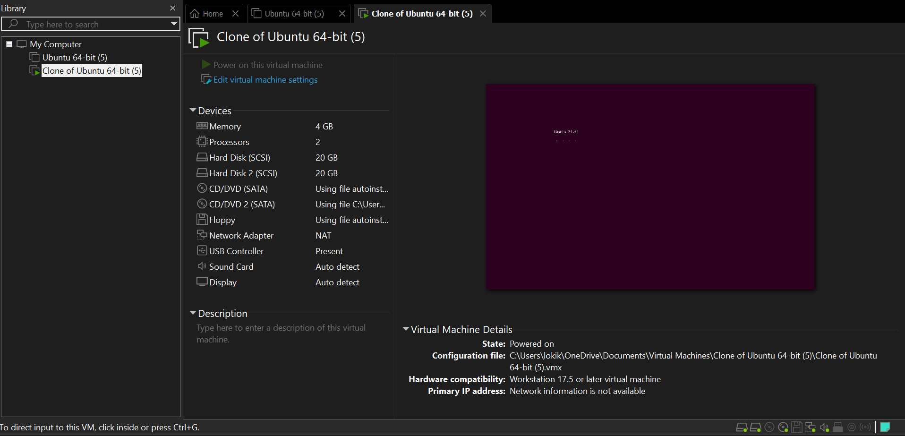

**Result**

The Virtual Machine was successfully cloned in Oracle VM VirtualBox using the full or linked cloning option. The cloned VM was started and tested, verifying that it loads correctly and operates independently from the original VM. This confirms that VM cloning provides a reliable way to duplicate and test VM states.